Select one of the following three questions (Q6, Q7, or Q8) to answer. Be sure to mark the “Select” circle 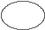 corresponding to the question that you select to answer on your answer sheet.
Note that if you select two or more questions, only the first question that you select will be scored.

Q6. Read the following description of a C program and the program itself, and then answer the sub-question.

[Program Description]
The function CountColors is a program that scans the image data in a specified rectangular region that is 320 pixels wide by 240 pixels high and counts the number of colors that are actually used. A pixel is stored in the following RGB structure:

typedef struct {
unsigned char Red ; /* Red brightness; 256 levels, from 0 to 255 */
unsigned char Green ; /* Green brightness; 256 levels, from 0 to 255 */
unsigned char Blue ; /* Blue brightness; 256 levels, from 0 to 255 */
} RGB ;

The image data is stored in a two-dimensional array of the RGB structures. The definition of the image data is shown below. The relationship between the image and the coordinate system is shown in the figure.

RGB Image[ 240 ][ 320 ] ;

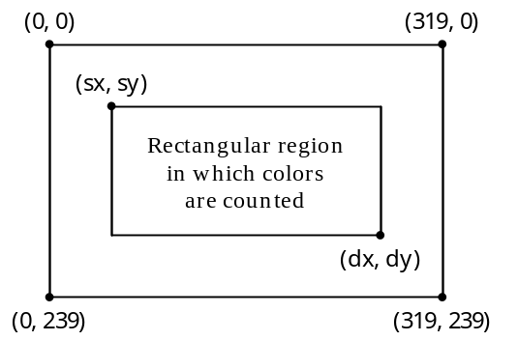
Fig. Coordinate System for Image Data

After the image data is loaded into the array Image, the function CountColors is called with the parameters that indicate the rectangular region in which the colors are to be counted. The number of colors is then returned by the function as a return value.
The prototype for the CountColors function is as follows:
long int CountColors( int sx, int sy, int dx, int dy );
The figure shows the relationship between the parameters and the point coordinates.

[Program]

typedef struct {
unsigned char Red ;
unsigned char Green ;
unsigned char Blue ;
} RGB ;

#define Width 320
#define Height 240
#define TRUE 1
#define FALSE 0

RGB Image[ Height ][ Width ] ;

long int CountColors( int sx, int sy, int dx, int dy )
{
int w, h ;
int px, py ;
long int Colors ;
int Counted[ Height ][ Width ] ;

for( h = sy ; h <= dy ; h++ )
for( w = sx ; w <= dx ; w++ )
Counted[h][w] = FALSE ;

Colors = 0 ;
for( py = sy ; py <= dy ; py++ )
for( px = sx ; px <= dx ; px++ ) {
if ( Counted[py][px] == FALSE ) {
 ;
Counted[py][px] = TRUE ;

for( h = py ; h <= dy ; h++ )
for( w = (  ) ; w <= dx ; w++ ) {
if ( Counted[h][w] == FALSE ) {
if (( Image[py][px].Red == Image[h][w].Red )
&&( Image[py][px].Green == Image[h][w].Green )
&&( Image[py][px].Blue == Image[h][w].Blue ))
 ;
}
}
}
}
return Colors ;
}
Sub-question
From the answer groups below, select the correct answers to be inserted in the boxes  in the program.

Answer group for “a”:
a) Colors = Counted[py][px] b) Colors = Counted[sy][sx]
c) Colors++ d) Colors−−
e) Counted[h][w] = FALSE f) Counted[h][w] = TRUE

Answer group for “b”:
a) h == py ? 0 : dx b) h == py ? px + 1 : sx
c) h == py ? sx : px + 1 d) h == sy ? 0 : dx + 1
e) h == sy ? sx : px + 1

Answer group for “c”:
a) Counted[dy][dx] = FALSE b) Counted[dy][dx] = TRUE
c) Counted[h][w] = FALSE d) Counted[h][w] = TRUE
e) Counted[py][px] = FALSE f) Counted[py][px] = TRUE
g) Counted[sy][sx] = FALSE h) Counted[sy][sx] = TRUE

